Hour
# Source: AI Source: Provided by: [Data Path: Persons Table -> ID Column: 1, Name_En Column: Motasem Essam] -> From: [ChatGPT] on [7/17/2026]
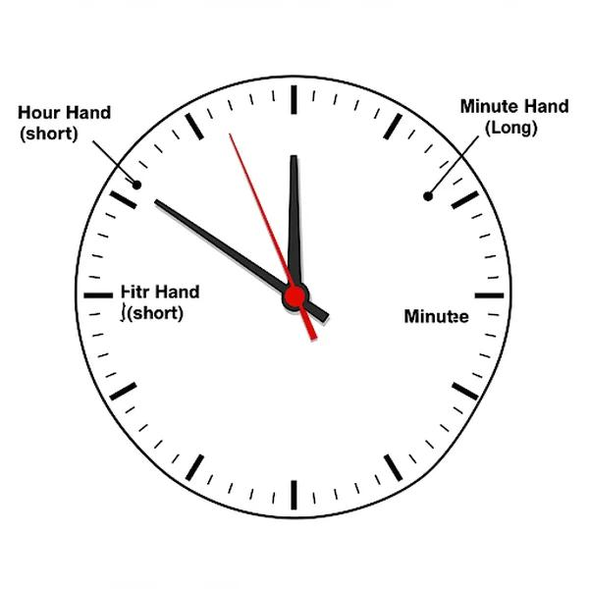
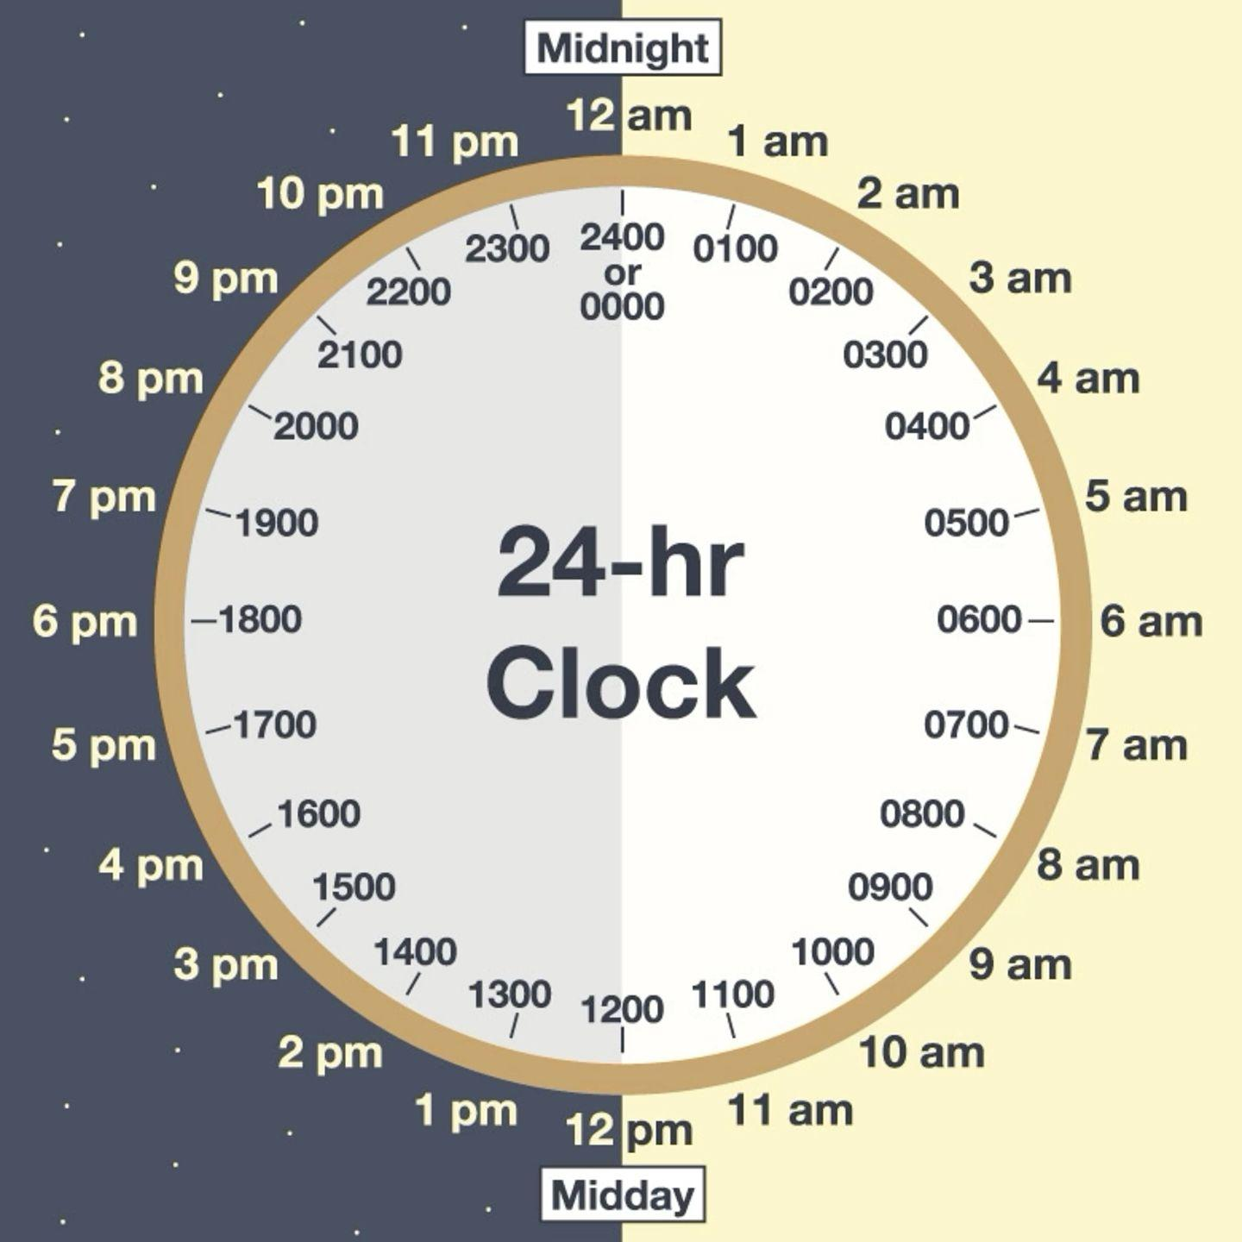
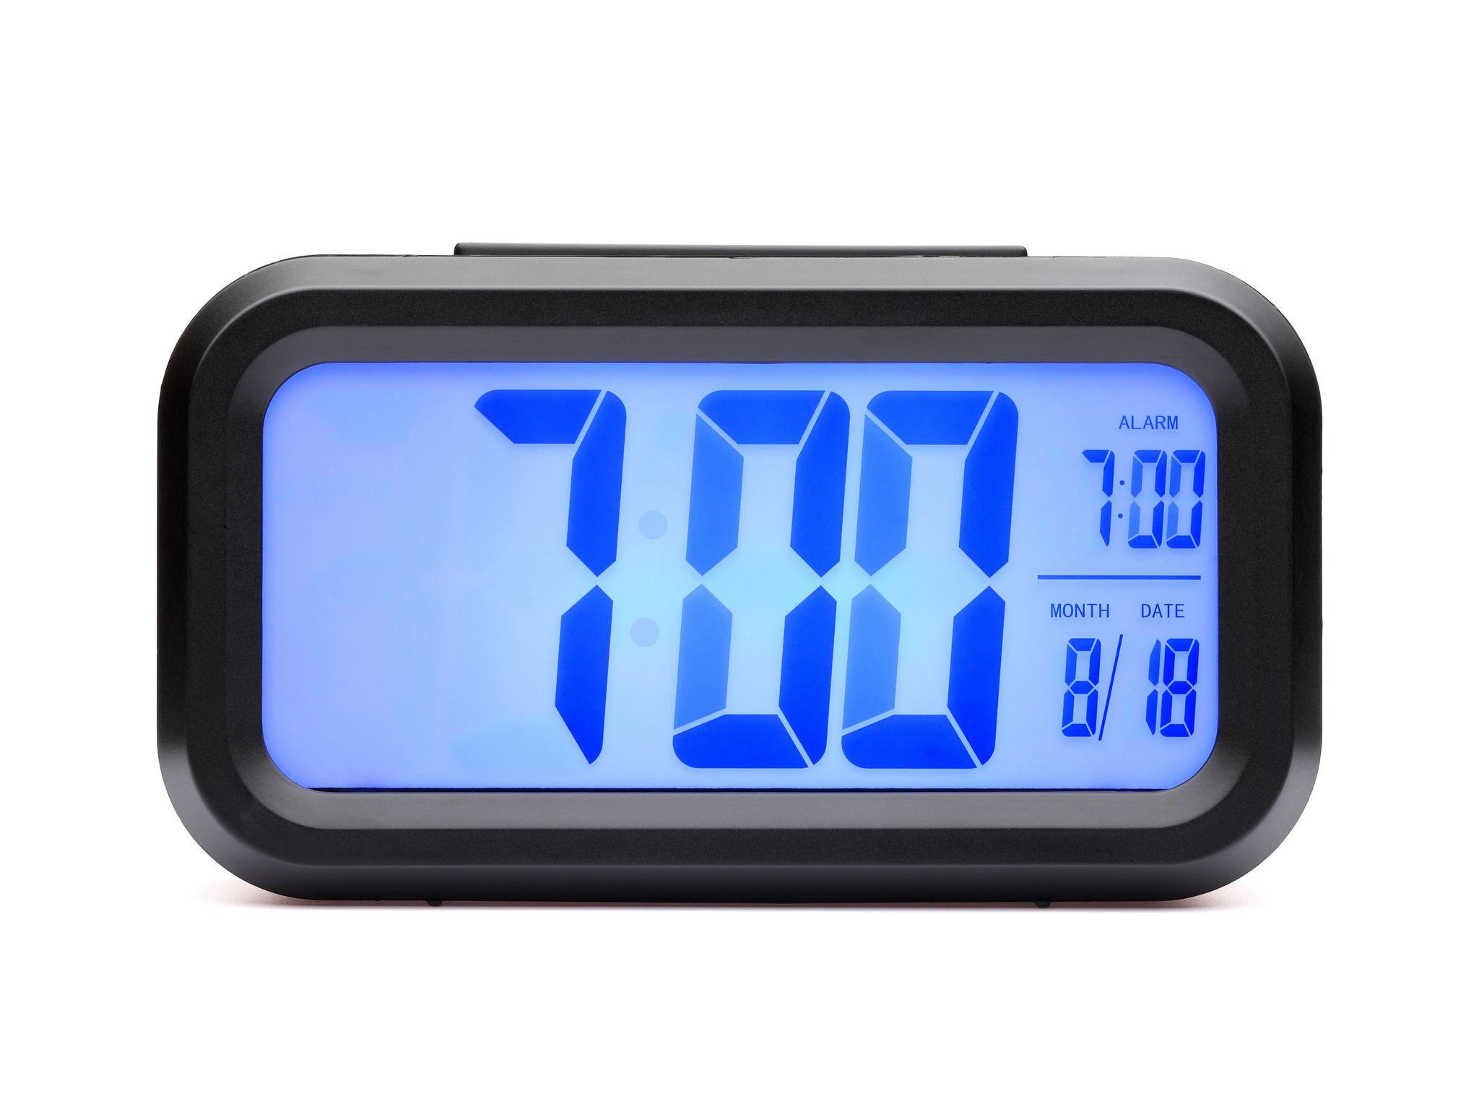
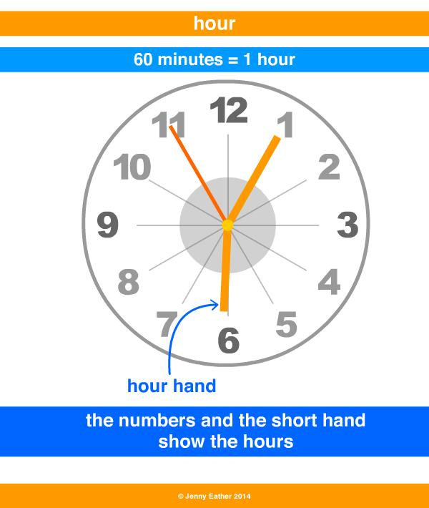
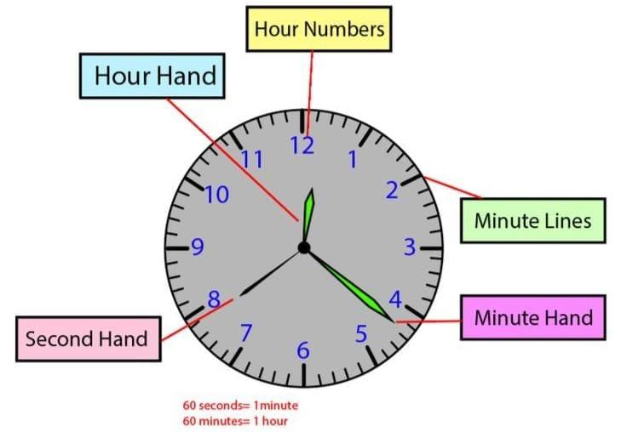
An Hour is a standard unit of time measurement equal to 60 minutes or 3,600 seconds. It is one of the most commonly used units for measuring daily time and is essential in scheduling, transportation, education, business, science, and everyday life.
An hour is larger than a minute and smaller than a day.

Definition
# Source: AI Source: Provided by: [Data Path: Persons Table -> ID Column: 1, Name_En Column: Motasem Essam] -> From: [ChatGPT] on [7/17/2026]
An Hour is a unit of time equal to 60 minutes or one twenty-fourth (1/24) of a day.

Standard Length
# Source: AI Source: Provided by: [Data Path: Persons Table -> ID Column: 1, Name_En Column: Motasem Essam] -> From: [ChatGPT] on [7/17/2026]
One hour equals:
- 60 minutes
- 3,600 seconds
Mathematically:
$$1\text{ hour}=60\text{ minutes}=3,600\text{ seconds}$$

Relationship to Other Time Units
# Source: AI Source: Provided by: [Data Path: Persons Table -> ID Column: 1, Name_En Column: Motasem Essam] -> From: [ChatGPT] on [7/17/2026]
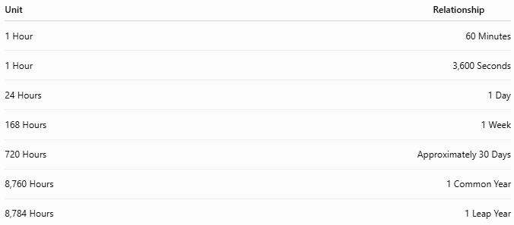
Unit | Relationship
1 Hour | 60 Minutes
1 Hour | 3,600 Seconds
24 Hours | 1 Day
168 Hours | 1 Week
720 Hours | Approximately 30 Days
8,760 Hours | 1 Common Year
8,784 Hours | 1 Leap Year

Abbreviations
# Source: AI Source: Provided by: [Data Path: Persons Table -> ID Column: 1, Name_En Column: Motasem Essam] -> From: [ChatGPT] on [7/17/2026]
Common abbreviations include:
- h (SI symbol)
- hr (common abbreviation)
Examples:
- 2 h
- 5 hr

Historical Background
# Source: AI Source: Provided by: [Data Path: Persons Table -> ID Column: 1, Name_En Column: Motasem Essam] -> From: [ChatGPT] on [7/17/2026]
The hour has its origins in ancient civilizations, including the Egyptians and Babylonians, who divided daylight and nighttime into equal parts. Later, the 24-hour day became the standard for measuring time.
The modern hour is defined as:
$$\frac{1}{24}$$
of a mean solar day.

Measuring Hours
# Source: AI Source: Provided by: [Data Path: Persons Table -> ID Column: 1, Name_En Column: Motasem Essam] -> From: [ChatGPT] on [7/17/2026]
Hours are measured using:
- Analog clocks
- Digital clocks
- Watches
- Smartphones
- Computer clocks
- Timers
- Stopwatches

Hour Hand on an Analog Clock
# Source: AI Source: Provided by: [Data Path: Persons Table -> ID Column: 1, Name_En Column: Motasem Essam] -> From: [ChatGPT] on [7/17/2026]
On a traditional analog clock:
- The hour hand is the shorter hand.
- It moves gradually as the minutes pass.
- It completes one full revolution every 12 hours.

Time Formats
# Source: AI Source: Provided by: [Data Path: Persons Table -> ID Column: 1, Name_En Column: Motasem Essam] -> From: [ChatGPT] on [7/17/2026]
12-Hour Format
Uses:
- AM (before noon)
- PM (after noon)
Examples:
- 7:00 AM
- 3:30 PM
- 11:45 PM

24-Hour Format
# Source: AI Source: Provided by: [Data Path: Persons Table -> ID Column: 1, Name_En Column: Motasem Essam] -> From: [ChatGPT] on [7/17/2026]
Widely used in:
- Military
- Aviation
- Railways
- Computing
- International communication
Examples:
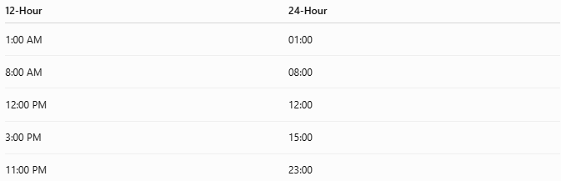
12-Hour | 24-Hour
1:00 AM | 01:00
8:00 AM | 08:00
12:00 PM | 12:00
3:00 PM | 15:00
11:00 PM | 23:00

Applications
# Source: AI Source: Provided by: [Data Path: Persons Table -> ID Column: 1, Name_En Column: Motasem Essam] -> From: [ChatGPT] on [7/17/2026]
Hours are used in:
- Daily schedules
- School timetables
- Business hours
- Transportation schedules
- Work shifts
- Scientific experiments
- Medical appointments
- Computing systems

Conversion Examples
# Source: AI Source: Provided by: [Data Path: Persons Table -> ID Column: 1, Name_En Column: Motasem Essam] -> From: [ChatGPT] on [7/17/2026]
Hours to Minutes
Multiply by 60.
Example:
$$2\text{ h}=2×60=120\text{ min}$$

Minutes to Hours
Divide by 60.
Example:
$$150\text{ min}=150÷60=2.5\text{ h}$$

Hours to Seconds
Multiply by 3,600.
Example:
$$3\text{ h}=3×3,600=10,800\text{ s}$$

Seconds to Hours
Divide by 3,600.
Example:
$$7,200\text{ s}=7,200÷3,600=2\text{ h}$$

Common Examples
# Source: AI Source: Provided by: [Data Path: Persons Table -> ID Column: 1, Name_En Column: Motasem Essam] -> From: [ChatGPT] on [7/17/2026]
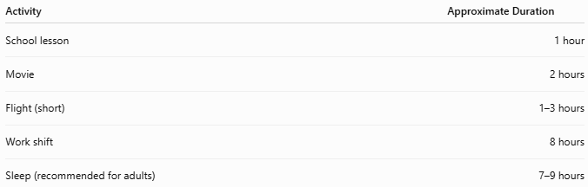
Activity | Approximate Duration
School lesson | 1 hour
Movie | 2 hours
Flight (short) | 1–3 hours
Work shift | 8 hours
Sleep (recommended for adults) | 7–9 hours

Advantages
# Source: AI Source: Provided by: [Data Path: Persons Table -> ID Column: 1, Name_En Column: Motasem Essam] -> From: [ChatGPT] on [7/17/2026]
Using hours allows:
- Standardized scheduling.
- Easy conversion to minutes and seconds.
- Accurate planning of daily activities.
- Consistent timekeeping worldwide.

Common Mistakes
# Source: AI Source: Provided by: [Data Path: Persons Table -> ID Column: 1, Name_En Column: Motasem Essam] -> From: [ChatGPT] on [7/17/2026]
- Assuming 100 minutes = 1 hour (it is 60 minutes).
- Confusing the hour hand with the minute hand on an analog clock.
- Misreading the 12-hour and 24-hour time formats.

Interesting Facts
# Source: AI Source: Provided by: [Data Path: Persons Table -> ID Column: 1, Name_En Column: Motasem Essam] -> From: [ChatGPT] on [7/17/2026]
- A day contains 24 hours.
- The hour hand completes:
  - 2 full rotations each day on a 12-hour analog clock.
- The symbol h is the internationally accepted abbreviation for hour.

Key Points
# Source: AI Source: Provided by: [Data Path: Persons Table -> ID Column: 1, Name_En Column: Motasem Essam] -> From: [ChatGPT] on [7/17/2026]
- An Hour equals:
$$60\text{ minutes}=3,600\text{ seconds}$$
- 24 hours = 1 day.
- Hours are measured using clocks, watches, and digital devices.
- The hour hand is the shorter hand on an analog clock.
- Hours are essential for scheduling, transportation, education, science, and everyday life.

Conclusion
# Source: AI Source: Provided by: [Data Path: Persons Table -> ID Column: 1, Name_En Column: Motasem Essam] -> From: [ChatGPT] on [7/17/2026]
An Hour is a fundamental unit of time equal to 60 minutes or 3,600 seconds, representing one twenty-fourth of a day. It plays a central role in daily life, providing a practical way to organize schedules, measure durations, and coordinate activities. Whether displayed on an analog clock, a digital device, or used in scientific calculations, the hour remains one of the most important and universally recognized units of time measurement.

